Coconut Supply Chain

# Model

The supply chain assumes the following actors:

* The coconut farmer
* The retailer (supermarket)
* The shipment company
* The customer

The process is as follows:

* Farmer grows the coconuts in a country different to the one in which the product will be sold
* Farmer puts the coconuts up for sale
* The supermarket’s buyer approaches the farmer to purchase the coconuts
  + It assumed that the buyer is in-house to the supermarket so the buyer and supermarket can be used interchangeably
* Buyer arranges shipment to the country of sale.
  + It is assumed the buyer has a pre-existing contract with the shipper so no payment necessary as part of this flow.
* Supermarket receives coconuts and puts them up for sale
* The customer buys the coconut(s)

# Architecture

## Activity

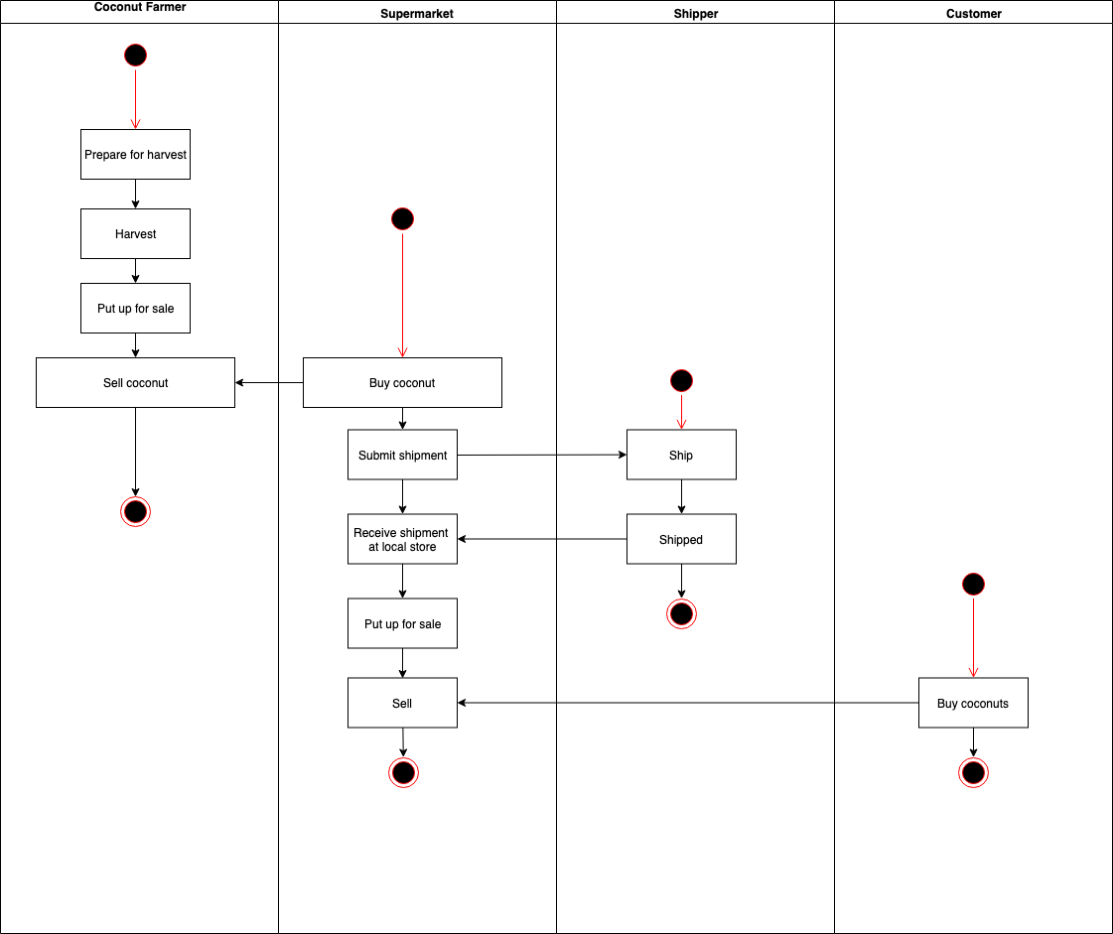

## Sequence

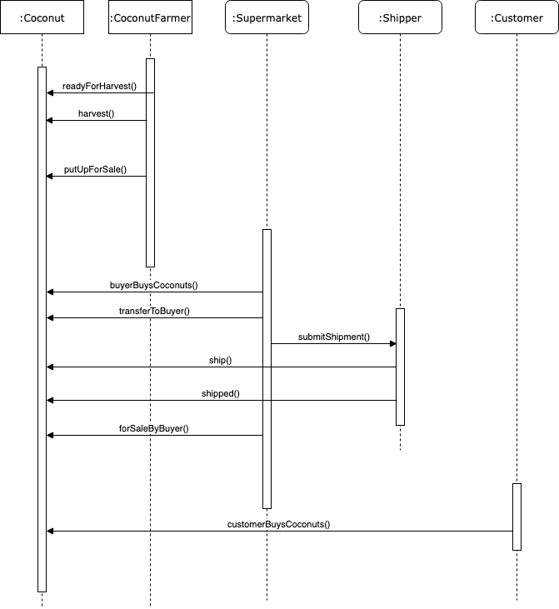

## State

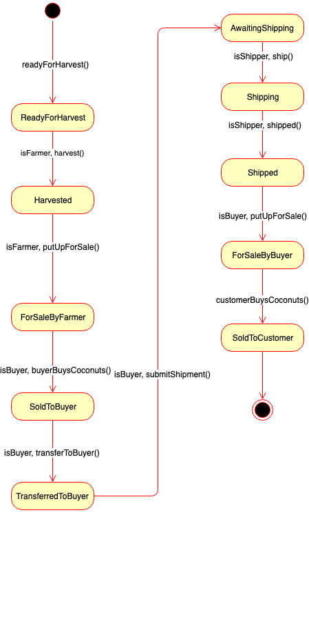

## Class

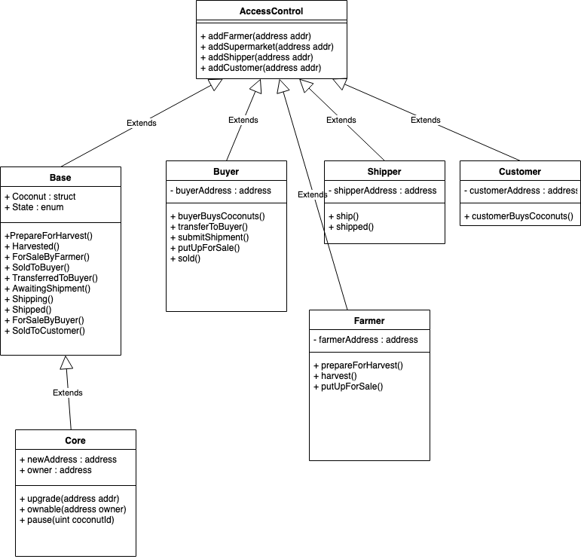

# Libraries

* OpenZeppelin’s SafeMath
  + For manipulating the markup on the coconut price when selling to the customer

# IPFS

# Deployment

See deployment.md

# Versions

Truffle v5.0.10 (core: 5.0.10)

Solidity - 0.5.2 (solc-js)

Node v11.13.0

Web3.js v1.0.0-beta.37